Integrate NodeJS with Gemini API’s.

Source: https://ai.google.dev/gemini-api/docs/text-generation?lang=node

Get Gemini API Key
Source: https://aistudio.google.com/

How to Create a Project in Google
Source: https://console.cloud.google.com

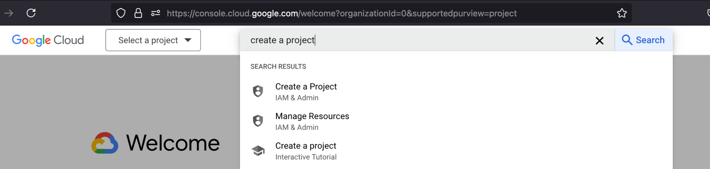

Generate text using the Gemini API

The simplest way to generate text using the Gemini API is to provide the model with a single text-only input, as shown in this example:
const gemini_api_key = process.env.API_KEY;
const googleAI = new GoogleGenerativeAI(gemini_api_key);
const geminiModel = googleAI.getGenerativeModel({
model: "gemini-1.5-flash",
});
var question = "what is the value of pie in maths ?";
const generate = async (question) => {
try {
const prompt = question;
const result = await geminiModel.generateContent(prompt);
const response = result.response;
console.log(response.text());
return response.text();
} catch (error) {
console.log("response error", error);
}
};
app.post('/api/content', async (req, res) => {
let data = req.body.question;
var result = await generate(data);
console.log(result);
res.json({"result" : result});
})

- Dependencies we need in our projects

const { GoogleGenerativeAI } = require("@google/generative-ai");
require('dotenv').config();
const express = require('express')
const axios = require('axios')
const multer = require('multer');
const bodyParser = require('body-parser');
const fs = require('fs')
const path = require('path');
const app = express()
const port = process.env.PORT || 3000
app.use(bodyParser.json());
app.use(express.json())
app.get('/', (req, res) => {
res.send('Hello World!')
})

